ish¿u ysñlï weúßKs $ All Rights Reserved

St. Peter's College

St. Peter's College

St. Peter's College

புனித பேதுரு கல்லூரி

புனித பேதுரு கல்லூரி

புனித பேதுரு கல்லூரி

புனித பேதுரு கல்லூரி

புனித பேதுரு கல்லூரி

புனித பேதுரு கல்லூரி

புனித பேதுரு கல்லூரி

புனித பேதுரு கல்லூரி

Ydka; mS;r úÿy,

Ydka; mS;r úÿy,

Ydka; mS;r úÿy,

Ydka; mS;r úÿy,

Ydka; mS;r úÿy,

Ydka; mS;r úÿy,

Ydka; mS;r úÿy,

Ydka; mS;r úÿy,

Ydka; mS;r úÿy,

Ydka; mS;r úÿy,

St. Peter's College

St. Peter's College

St. Peter's College

St. Peter's College

St. Peter's College

St. Peter's College

St. Peter's College

St. Peter's College

St. Peter's College

St. Peter's College

புனித பேதுரு கல்லூரி

புனித பேதுரு கல்லூரி

புனித பேதுரு கல்லூரி

புனித பேதுரு கல்லூரி

புனித பேதுரு கல்லூரி

புனித பேதுரு கல்லூரி

புனித பேதுரு கல்லூரி

புனித பேதுரு கல்லூரி

Ydka; mS;r úÿy,

Ydka; mS;r úÿy,

Ydka; mS;r úÿy,

Ydka; mS;r úÿy,

Ydka; mS;r úÿy,

Ydka; mS;r úÿy,

Ydka; mS;r úÿy,

Ydka; mS;r úÿy,

Ydka; mS;r úÿy,

Ydka; mS;r úÿy,

St. Peter's College

St. Peter's College

St. Peter's College

St. Peter's College

St. Peter's College

St. Peter's College

St. Peter's College

31

E

**I,II**

**bx.%Sis**

**English**

**meh**

**Hour**

**02**

**07 fY%aKsh – fojk jdr we.hsu - 2023**

***Grade 07 – Second Term Examination - 2023***

Ydka; mS;r úÿy, - fld<U 04

புனித பேதுரு கல்லூரி, கொழும்பு 4

***St. Peter's College - Colombo 04***



Name:……………………………………………………….. Class:………. No:……….

² **Answer all the questions.**

01. Fill in the blanks with correct letters.

1. philo__op__er. 2. exp__ri__nce. 3. a__ve__ture.

4. t__ph__id. 5. steg__s__urus. 6. at__osp__ere.

7. b__ct__rium 8. A__p__ibian 9. Pale__ntol__gist

10. C__nt__minated **(10 Marks)**

02. Combine the sentences using **and / but / or**

**Eg:** *I can play tennis tomorrow.*

*I can play tennis on Friday.*

***I can play tennis tomorrow and on Friday.***

i. Do you like cake?

Do you like pudding?

___________________________________________

ii. I wanted to watch the movie.

You did not come.

___________________________________________

iii. Today is cold.

Yesterday was very warm.

___________________________________________

iv. Do you want to eat now?

Do you want to eat later?

___________________________________________

v. It was very sunny last Sunday.

We went to the beach.

___________________________________________ **(05 Marks)**

03. Fill in the blanks with correct possessive pronouns.

**Eg: This photo belongs to her. It’s hers.**

i. That table belongs to Mr. and Mrs. Somasiri.

That is ______________________________

ii. Those flowers belong to Nayana. Those are ____________

iii. This house belongs to Ken. It is ____________

iv. This dress belongs to me. It’s ____________

v. The kite belongs to me and my sister. It is ____________ **(05 Marks)**

04. Complete the puzzle with the appropriate **adverbs**.

$$5$$

**F**

$$5$$

**F**

$$6$$

**S**

$$5$$

**T**

$$5$$

**S**

$$5$$

**M**

$$5$$

**P**

$$5$$

**M**

$$5$$

**Y**

$$5$$

**P**

$$7$$

**H**

$$5$$

**P**

$$5$$

**L**

$$5$$

**P**

$$5$$

**Y**

$$5$$

**Y**

$$5$$

**I**

$$5$$

**Y**

$$5$$

**E**

$$4$$

**E**

$$5$$

**E**

$$2$$

**G**

$$4$$

**E**

$$5$$

**Y**

$$5$$

**L**

$$5$$

**Y**

$$5$$

**E**

$$4$$

**E**

$$5$$

**E**

$$3$$

**S**

$$4$$

**E**

$$4$$

**E**

$$4$$

**D**

$$4$$

**A**

$$4$$

**Y**

$$4$$

**D**

$$4$$

**U**

$$1$$

**S**

$$4$$

**D**

$$4$$

**D**

**Across**

4. He conduct strange

experiments _______

5. Squirrel ran _______

bush to bush.

7. We play in the school

playground _______

**Down**

1. Our teacher made us work on _______

2. Children ate the ice cream _______

3. Maurice is a good singer. She sings___

6. He lives _______ and loves all.

**(07 Marks)**

05. Design a poster on one of the topics with appropriate slogans.

* Health habits
* Dengue Menace

_______________________________

**(08 Marks)**

06. Fill in the blanks of the sentences with the given collective nouns.

**[flight of stairs , pile of stones , herd of elephants , bouquet of flowers , pair of scissors]**

i. You need a _____________________ to cut the cloth.

ii. It was difficult to climb the _____________________ as I had a bad foot.

iii. A _____________________ rampaged the village and destroyed all the crops.

iv. The vehicle knocked on the _____________________ that was stocked beside the pavement.

v. The students welcomed the teacher with a _____________________ when she arrived.

**(05 Marks)**

07. Here is a note you received from your friend. Write a reply. (Use about 30 words)

Ranidu,

Will you be free on next Sunday? We are planning to play a cricket match in the playground next to Ravi’s house. Can you join us? If so please let me know without delay.

Sudam

_________________

__________________________________________________________________________________________________________________________________________________________________________________________________________________________________________________________________________________________________________________________________________________________________________________

____________________

**(05 Marks)**

08. Observe what is happening in the picture and write 05 sentences about it.

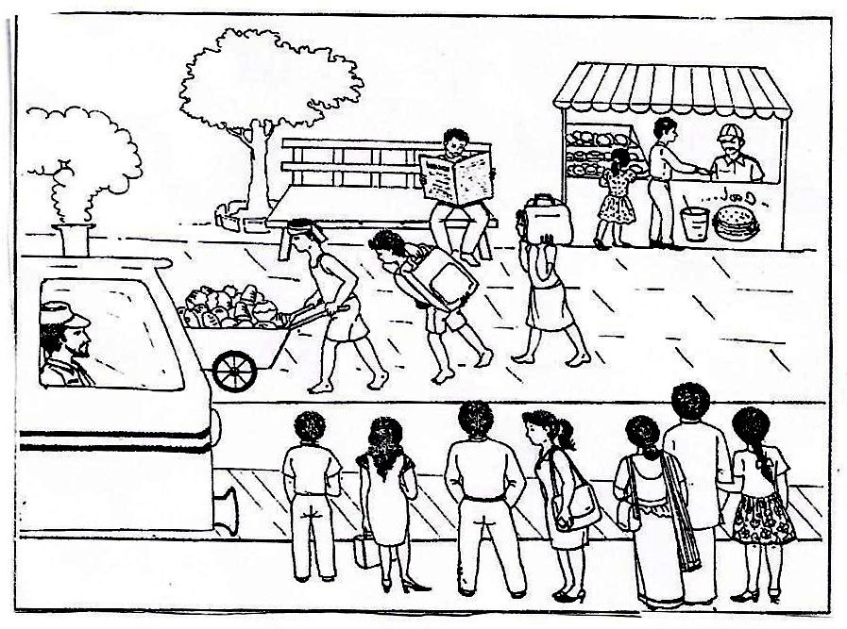

______________________________________________________________________________________________________________________________________________________________________________________________________________________________________________________________________________________________________________________________________________________________________________________________________________________________________________________________________________________________________________________________________

**(05 Marks)**

09. Fill the missing forms of adjectives in the following activity.

**Positive Comparative Superlative**

***Eg: Bright brighter brightest***

1. _____________ smaller _____________

2. Old _____________ _____________

3. _____________ more interesting _____________

4. _____________ faster _____________

5. Many _____________ _____________

**()**

10. Read the following passage and answer the questions given below.

Rice is low in fat and high in energy, and you can mix it with just about anything to make a wide variety of tasty nutritious dishes. Rice is closely associated with the culture of many societies. Buddhists and Hindus use rice in religious offerings and wedding ceremonies. Burmese folklore uses rice as central part of their creation story. The God gave the first people of Burma rice seeds and directed them to Burma, where the rice would grow well. Chinese myths tell now, after several floods there was nothing to eat and the people were starving. One day they saw a dog coming across the fields and hanging on the dog’s tail were bunches of long yellow seeds. The seeds grew into rice and people survive.

Rice is the staple food of many countries. As the world population increases rice production has to be increased by at least 70% over the next three decades. The area devoted to rice cultivation cannot grow so much.

International research is being done to find ways of growing rice on less land.

A. 1. Name the two main qualities that rice contain.

i. _________________________ ii. _________________________

2. Who uses rice in religious offerings?

_______________________________________

3. What did the God give the first people of Burma?

_______________________________________

4. What happened to the Chinese after the severe floods according to the myths?

_______________________________________

5. What do researchers try to find?

_______________________________________ **(05 Marks)**

**B.** Match the phrases with the meaning and write the relevant number against the boxes given.

1. The life style of a certain community staple food

2. The people who saved their lives population

3. The main food item of people culture

4. The number of people in a community starving

5. Going without food survivors

**(05 Marks)**

11. Write an essay on one of the topic given below. Use about 150-175 words.

A - “Prevention is better than cure”

B - An educational trip that you went recently.

C - A famous person in Sri Lanka.

________________________________________

__________________________________________________________________________________________________________________________________________________________________________________________________________________________________________________________________________________________________________________________________________________________________________________________________________________________________________________________________________________________________________________________________________________________________________________________________________________________________________________________________________________________________________________________________________________________________________________________________________________________________________________________________________________________________________________________________________________________________________________________________________________________________________________________________________________________________________________________________________________________________________________________________________________________________________________________________________________________________________

**(15 Marks)**

12. **Listening**

Underline the correct answer by listening to the weather report.

i. Tomorrow’s weather will be,

a. sunny

b. windy

c. rainy

ii. Temperature will range from,

a. ${30-40}^{C}$

b. ${40-50}^{C}$

c. ${30-32}^{C}$

iii. There will be scattered shower in,

a. Matara and Galle

b. Galle

c. Matara

iv. Central and Uva province will experience,

a. heavy showers

b. thunder showers

c. scattered shower

v. The weather will be windy in the _______,

a. southern part

b. eastern part

c. northern part

vi. This announcement is about,

a. sports

b. obituary

c. weather

vii. The weather report was given by,

a. Sirasa FM

b. Ada Derana

c. Sri Lanka broadcasting corporation

viii. The other parts of country will experience,

a. cold weather

b. dry weather

c. windy weather

**(08 Marks)**

13. Speech : **(12 Marks)**